**Headphone Amplifier using IC-741**

**A PROJECT REPORT**

**Submitted by**

Sahil Mandi (BT21ECE098) | Anjalika Agrawal (BT21ECE095) | Mohit Kumar (BT21ECE091)

*B.Tech. 3rd semester minor project*

*of*

**Analog Electronics and Integrated Circuits**

*in*

**Electronics and Communication Engineering**



**Indian Institute of Information Technology**

**Nagpur**

**November 2022**

**ACKNOWLEDGEMENT**

We would like to express our special thanks of gratitude to our course Coordinator Dr. Girish Ghivela and Dr. Tappan Jain who gave us the golden opportunity to do this wonderful project on the topic Analog Electronics and Integrated Circuits, which also helped us in doing a lot of research and we came to know about so many new things, we are really thankful to them.

Secondly, we would also like to thank our batchmates who helped us a lot in finalizing this project within the limited time frame.

|  |  |
| --- | --- |
| Date : 9 nov 2022 | Sahil Mandi (BT21ECE098) |
|  | Anjalika Agrawal (BT21ECE095) |
|  | Mohit Kumar (BT21ECE091) |

**TABLE OF CONTENTS**

|  |  |  |
| --- | --- | --- |
|  | **TITLE** |  |
|  | **ABSTRACT** | **i** |
| **1.0** | **INTRODUCTION** | **1** |
|  | 1.1 Sub section | 1 |
|  | 1.2 Sub section | 1 |
| **2.0** | **LITERATURE REVIEW** | **2** |
|  | 2.1 Sub section | 2 |
|  | 2.2 Sub section | 2 |
| **3.0** | **METHODOLOGY** | **3** |
|  | 3.1 Sub section | 3 |
|  | 3.2 Sub section | 3 |
| **4.0** | **EXPERIMENTATION** | **4** |
|  | 4.1 Sub section | 4 |
|  | 4.2 Sub section | 4 |
| **5.0** | **RESULT AND DISCUSSION** | **5** |
|  | 5.1 Sub section | 5 |
|  | 5.2 Sub section | 5 |
| **6.0** | **CONCLUSION** | **6** |
| **7.0** | **FUTURE SCOPE** | **7** |
|  | **REFERENCES** | **8** |

**ABSTRACT**

The goal of this project is to expand our knowledge in the domain of analog electronics, more specifically to learn about Operational amplifiers and various IC like 741 and 555 and their practical application.

This project demonstrates the use of IC-741 as a audio signal amplifier designed to be used with high impedance headphones, which delivers a distortion free amplified signal.

The Scope of this project is to establish:

* Understanding the fundamental concepts of Analog Electronics.
* Develop hands on experience on circuit designing and problem solving.
* Learn team work and establish foundation for good communication skills.

This report covers the following concepts and topics:

* Operational Amplifiers
* IC -741
* AC Circuits (Fundamentals)
* BJT
* Power Amplifier
* Classes in power amplifier
* Class AB amplifier
* Audio Signal
* Headphones and Impedance

1. **INTRODUCTION**

1. **LITERATURE REVIEW**

It evaluates the current work with the previous one. It depicts the current implementations that overcome the previous problems and limitations of the project, and draws the attention and focus on the foreknowledge work that would be conducted based on the ongoing work at present. It must be clear and simple to understand.

1. **METHODOLOGY**

Essentially, a methodology is a collection of methods, practices, processes, techniques, procedures, and rules

Explain your methodological approach.

Describe your methods of data collection and/or selection.

Describe your methods of analysis.

Evaluate and justify your methodological choices.

Table 3.1 : Title of the table

|  |  |  |
| --- | --- | --- |
| **Heading** | **Heading** | **Heading** |
| Data | Data | Data |
| Data | Data | Data |

Figure 3.1 : Title of the image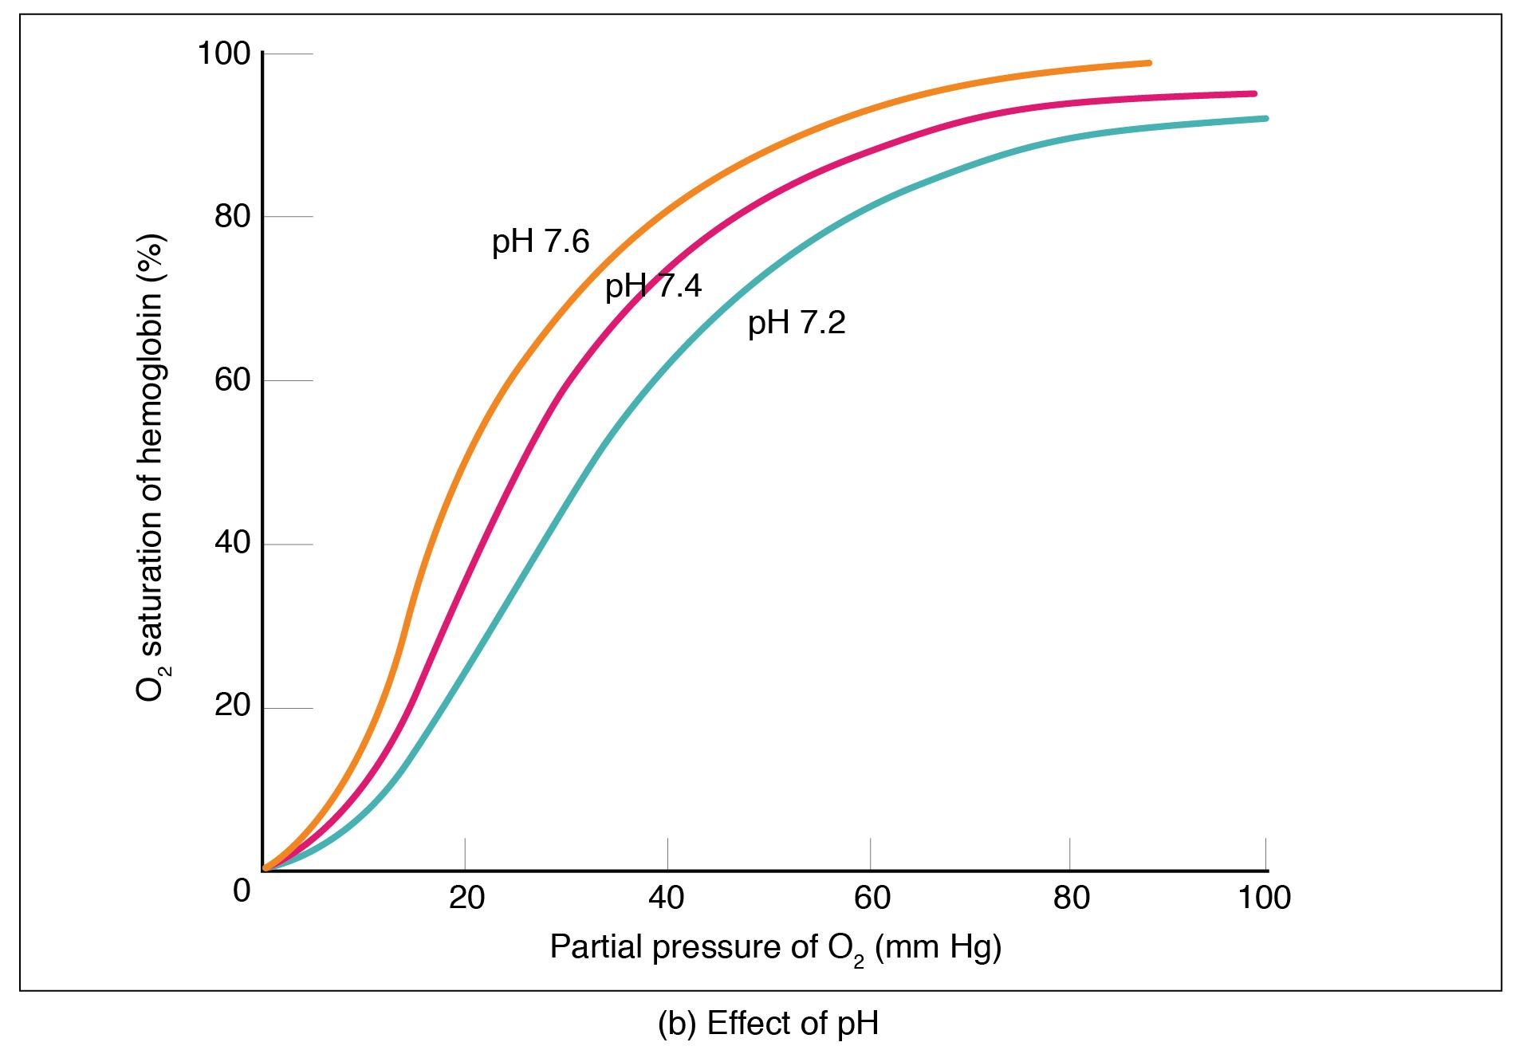

1. **EXPERIMENTATION**

Write the experimental procedure like a step-by-step recipe for your science experiment. A good procedure is so detailed and complete that it lets someone else duplicate your experiment exactly!

1. **RESULT AND DISCUSSION**

This section should be written in the present tense. The Discussion section needs to follow from your results and relate back to your literature review.

Interpret and explain your results.

Answer your research question.

Justify your approach.

Critically evaluate your study.

1. **CONCLUSION**

The conclusion and recommendations part summarizes the whole report by highlighting all the chapters and their significance and the importance of the project and the achievements.

1. **FUTURE SCOPE**

Scope for future development if any

**REFERENCES**

1. Shin, K.G. and Mckay, N.D. (1984) ‘Open Loop Minimum Time Control of Mechanical Manipulations and its Applications’, Proc.Amer.Contr.Conf., San Diego, CA, pp. 1231-1236.